The code runs on a linux environment (pyrite servers is where it was compiled and tested)

To Run

1. Execute command javac Server.java
2. Execute command g++ -o client Client.cc util.cc
3. Execute command java Server to start the server
4. Execute command ./client to start the client
5. Follow onscreen instructions

Test Cases

Input: Test

Output Expected: True

Actual Output: True

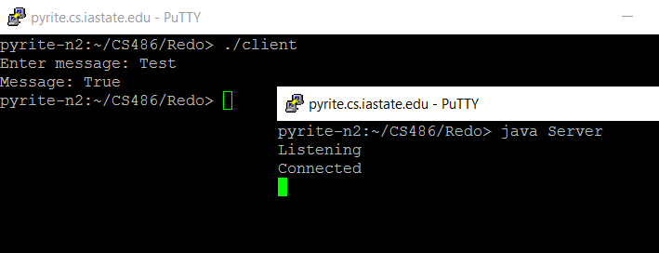

Input: Test

Output Expected: False (Changed key on server to be different from client)

Actual Output: False

